**Experiment - 6**

1.

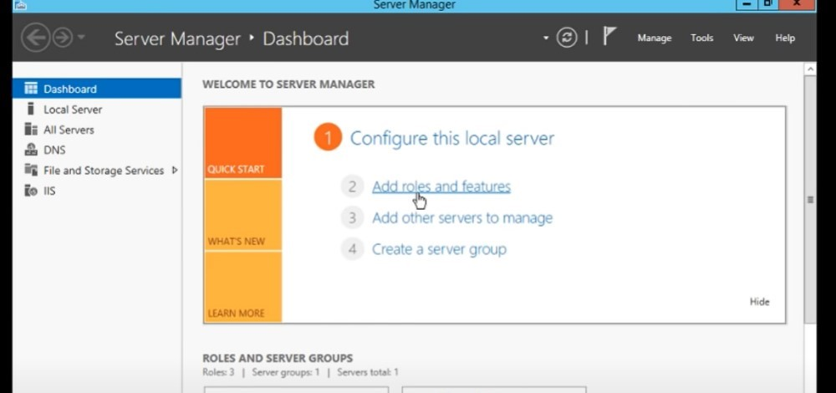

2

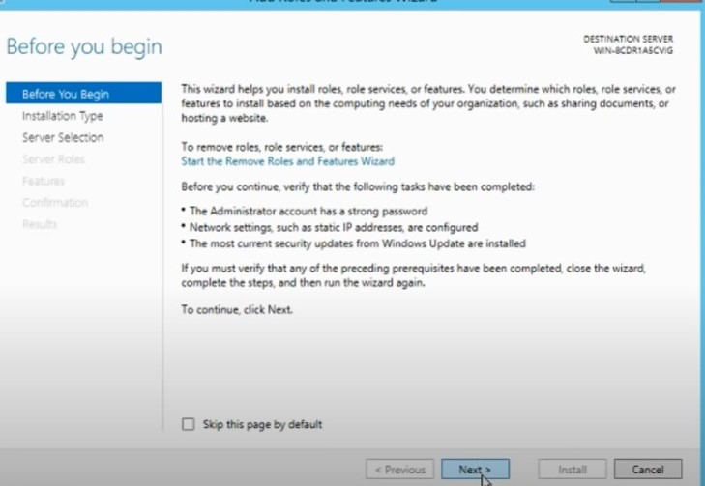

3

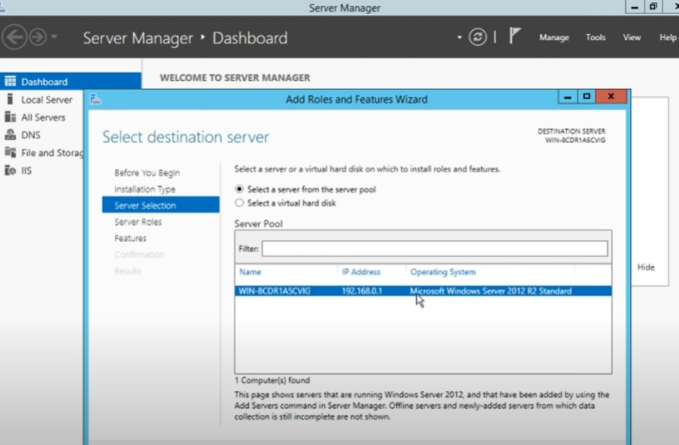

3-2

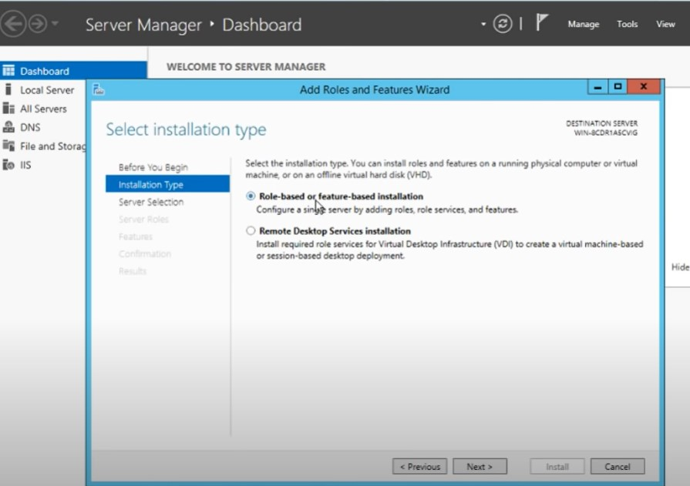

4

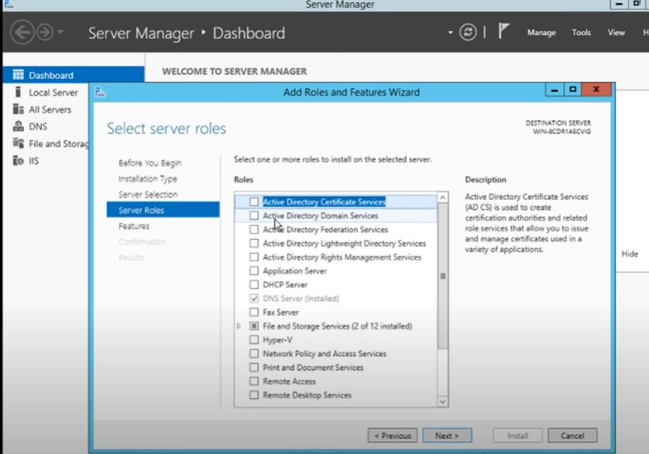

5

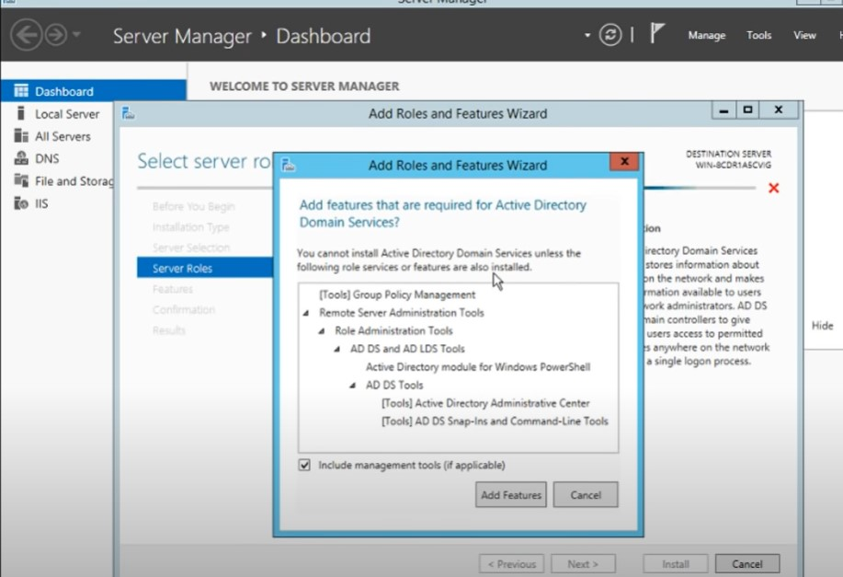

6

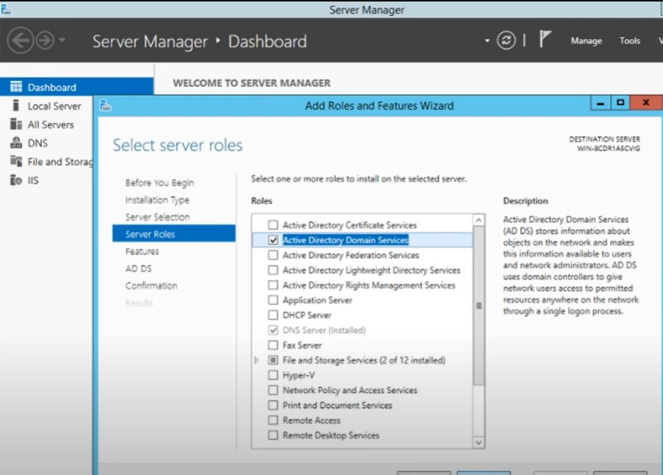

7

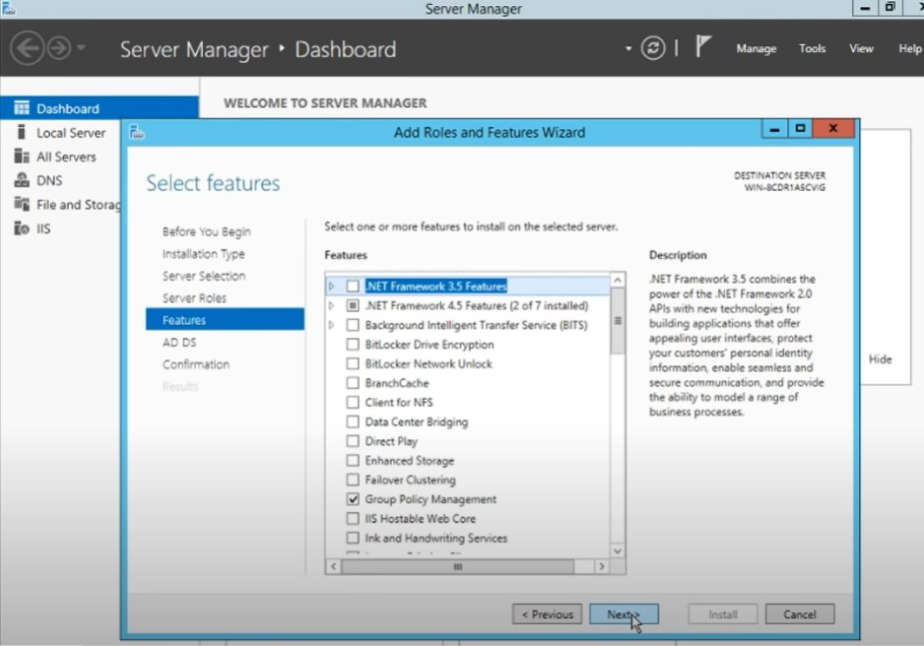

8

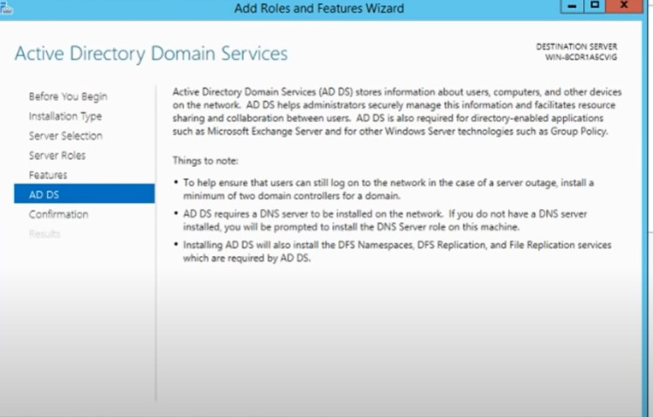

9 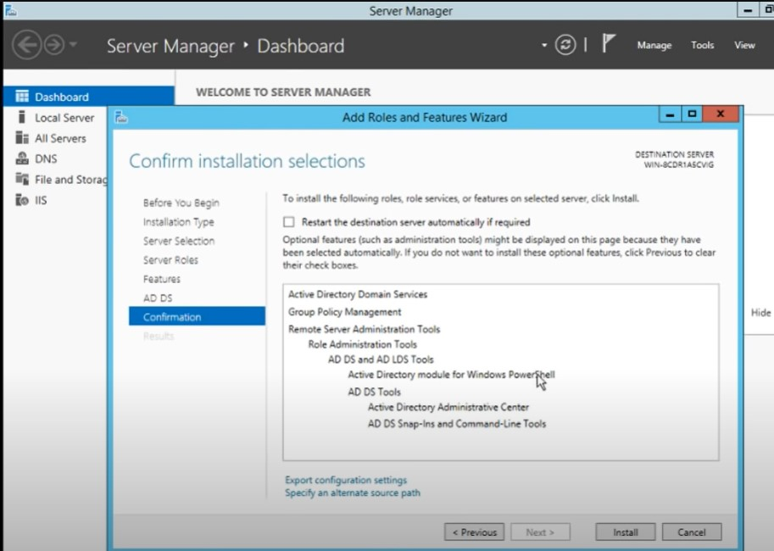

10 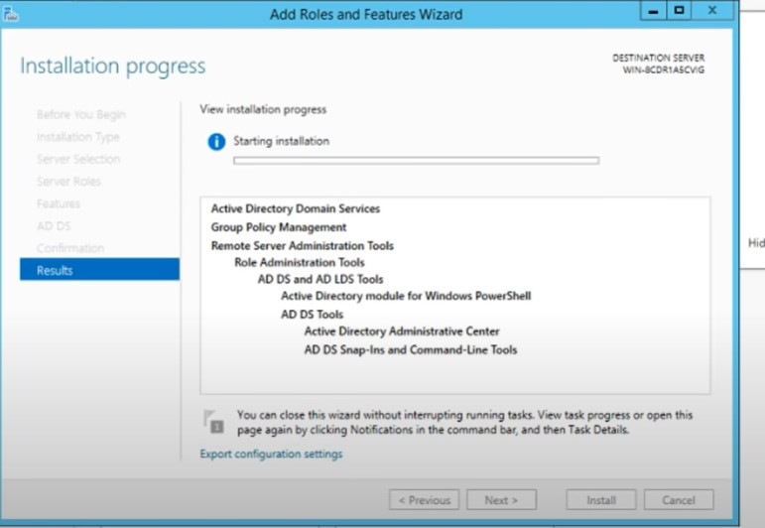

11 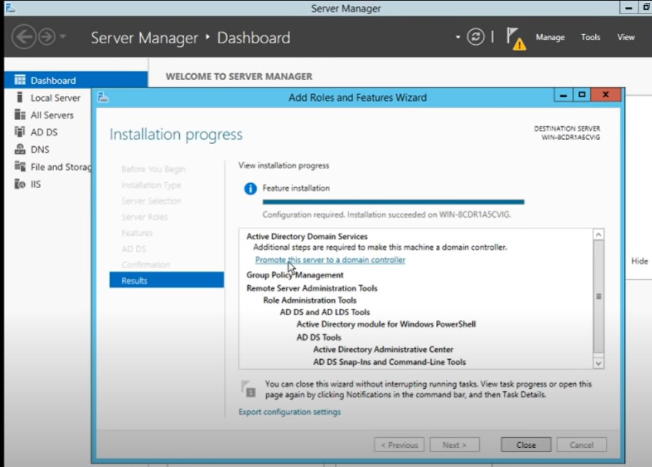

12

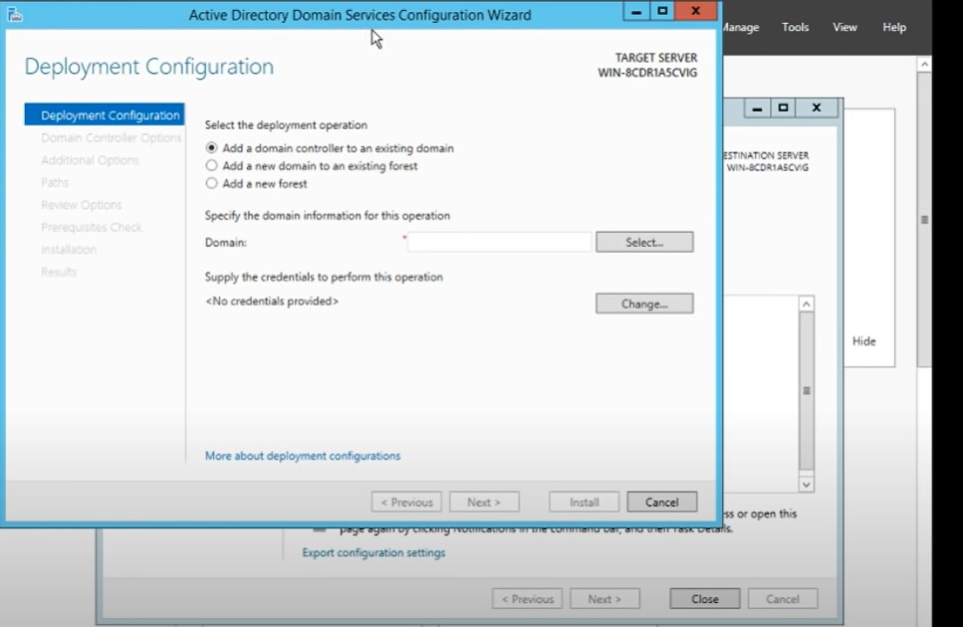

13

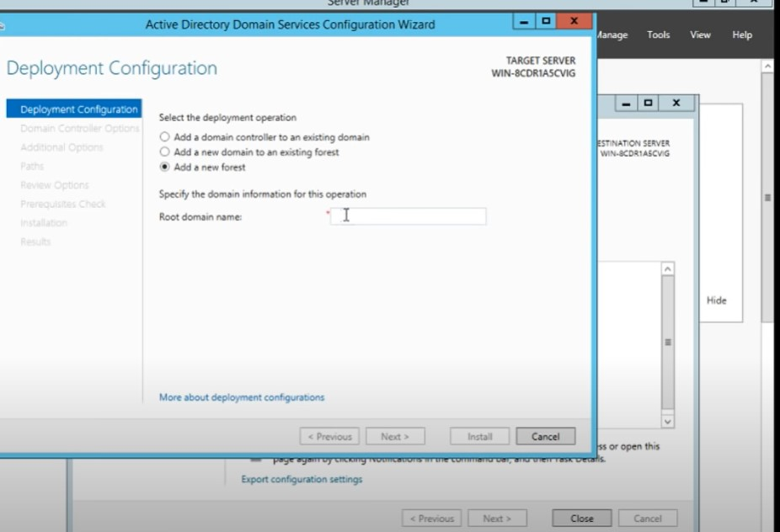

14

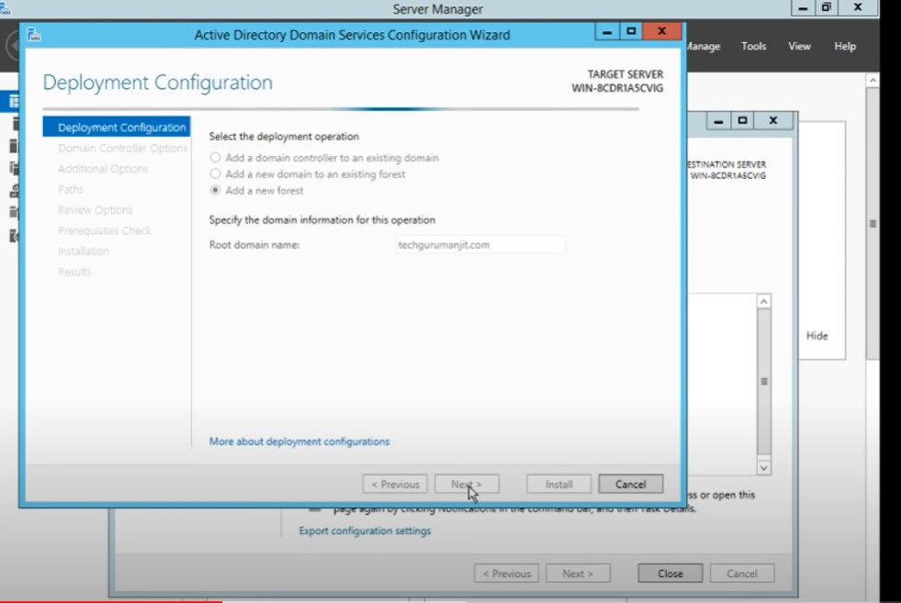

15

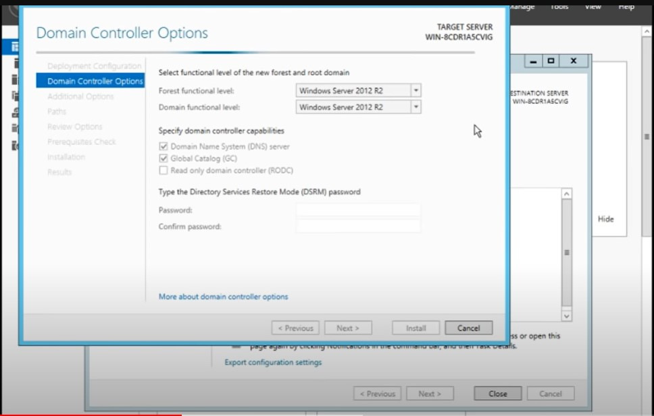

16

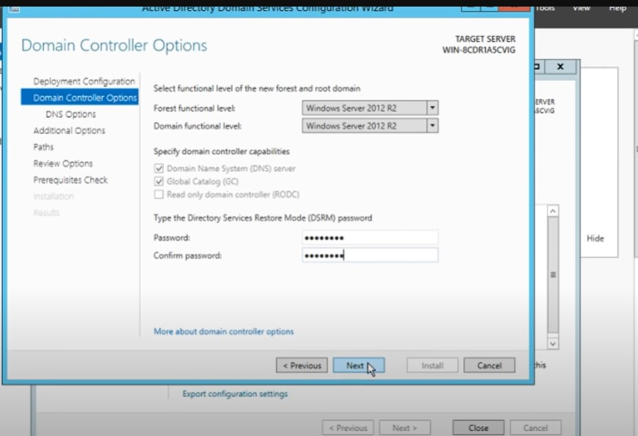

17

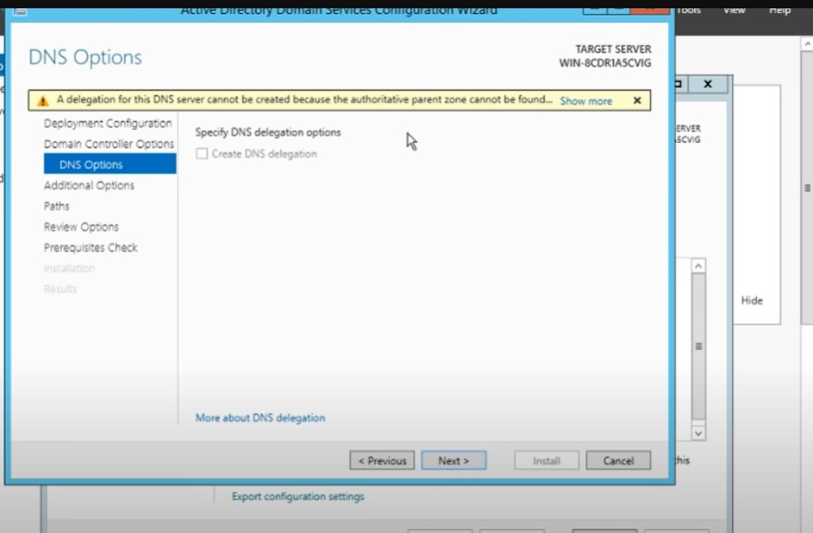

18 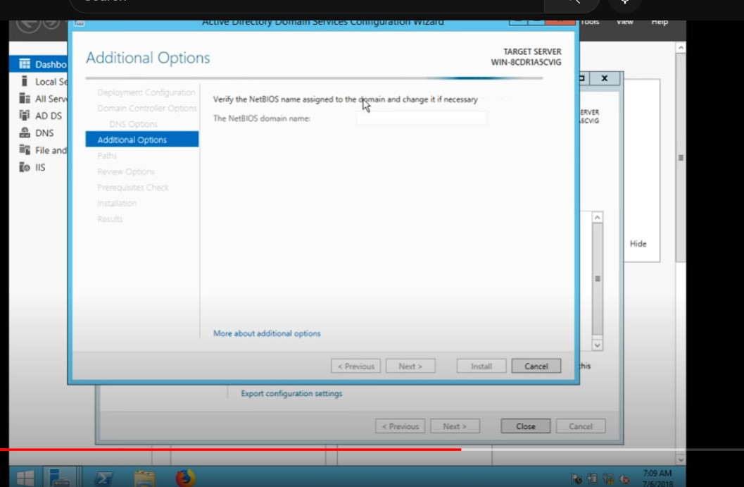

19

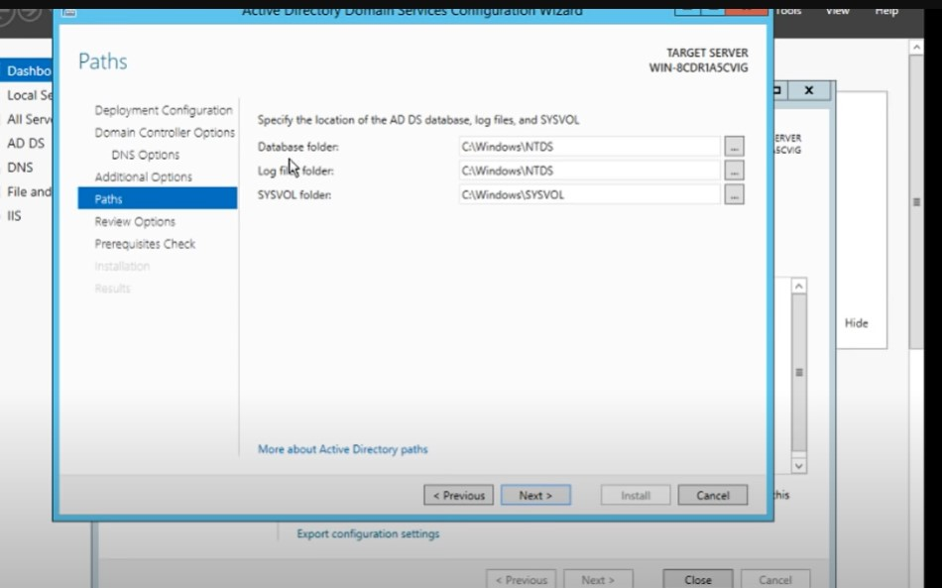

20

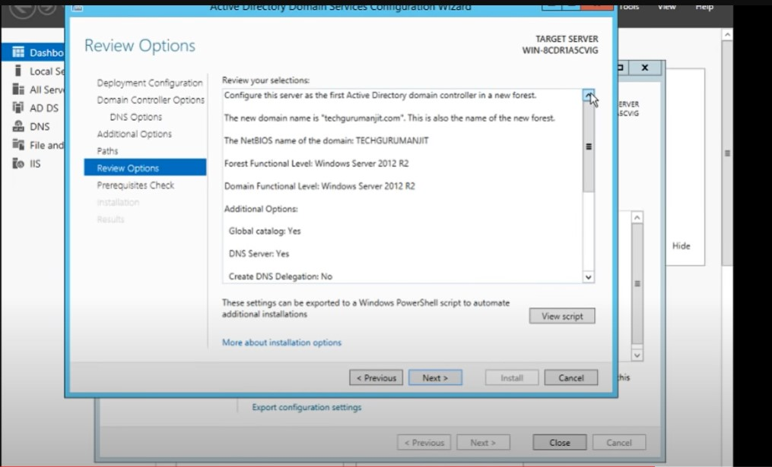

21

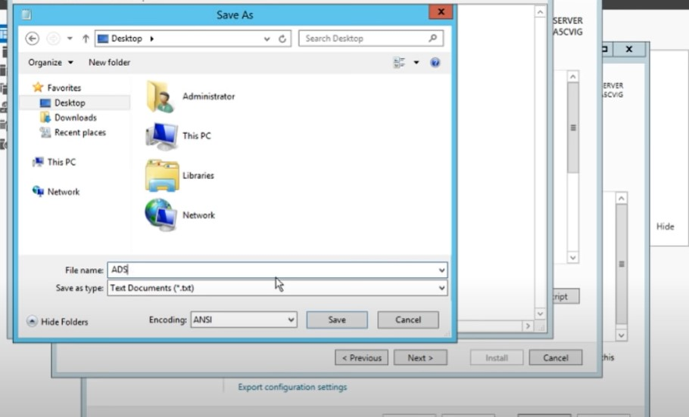

22

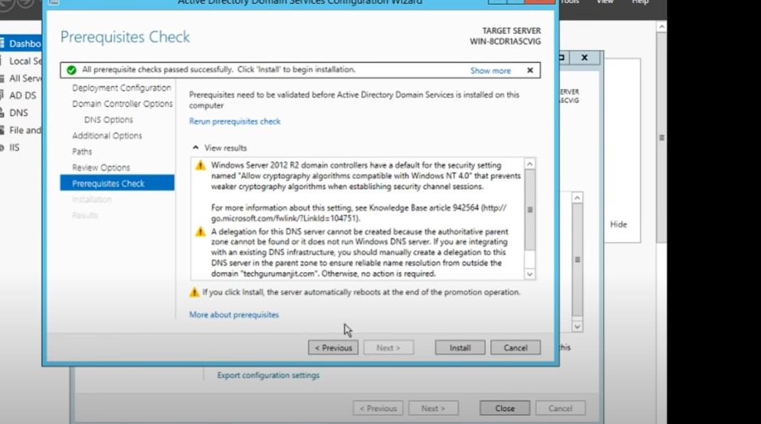

23

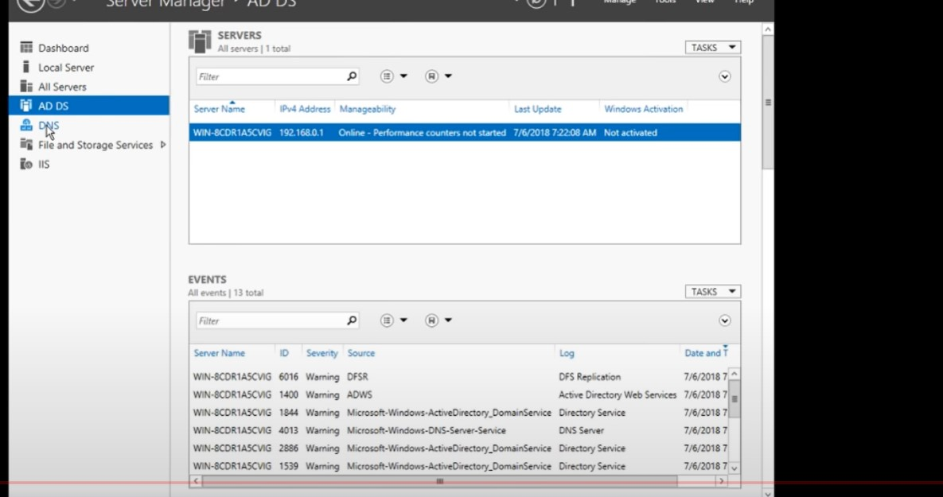

#### Experiment 7

**Aim:** Add backup feature and migrate roles from previous versions of windows server

**Co Attained: CO3:** Prepare students for placements in Companies focusing on Networking and Server environment and further being research oriented in the field of Computer Networks.

**Procedure:**

1. Log on to the domain controller as the default Administrator or a member of the Backup Operators group. On the Start menu, click Administrative Tools and select Windows Server Backup. The Windows Server Backup window is displayed.
2. In the right pane, select Backup Once.

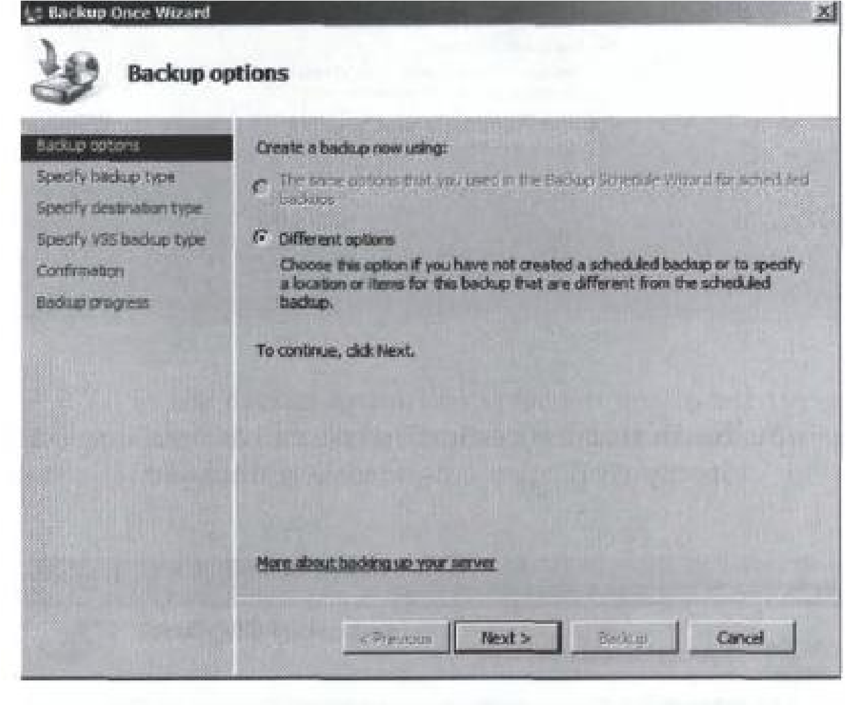

1. Because you have not configured scheduled backups, the only available option is the Different Options radio button. Click Next to continue. The Select backup configuration window is displayed.
2. If you are backing up to a local device, select Custom and click Next. The Select backup items window is displayed.
3. Ensure that the destination volume has been deselected and click Next. The Specify destination type window is displayed.
4. Select a local drive or a remote shared folder to store this backup and click Next. The Select backup destination window is displayed.
5. In the Backup destination dropdown box, select the appropriate backup destination and click Next. The Specify advanced option window is displayed.
6. Select one of the following backup types and click Next. The Confirmation window is displayed.
   1. Copy backup. This backup type will retain the Application log files on the local server. Select this backup type if you will be using a third-party backup tool in addition to Windows Server Backup.
   2. VSSfull backup. This backup type will update each file's backup history and will clear the Application Log files.
7. To begin the backup process, click Backup. The Backup progress window is displayed.
8. When the backup is complete, click Close.

PAUSE. LEAVE the Windows Server Backup window open for the next exercise.

Configure Scheduled Active Directory Backups

To perform this exercise you must be logged into the server as a member of the Administrators group. To perform this backup, you must have a second hard drive volume available that is at least 1 MB larger than the critical volumes of the server that you are backing up. These steps assume that you are backing up to a local volume. You must also have the Window Server Backup feature installed on the Windows Server 2008 computer; this can be installed from the Server Manager console if you have not done so already.

1. Log on to the domain controller as the default Administrator or a member of the Backup Operators group. On the Start menu, click Administrative Tools and select Windows Server Backup. The Windows Server Backup window is displayed.
2. In the right pane, select Backup Schedule. The Getting Started window is displayed.
3. Click Next. The Specify Backup Type window is displayed.
4. If you are backing up to a local device, select Custom and click Next. The Select Backup Items window is displayed.
5. Verify that the destination volume has not been selected and click Next. The Specify backup time window is displayed
6. Select the time that you want the backups to take place and click Next. The Select Destination Disk window is displayed.
7. If your backup destination disk does not appear automatically, click Show All Available Disks, place a checkmark next to the destination, and click OK.
8. Place a checkmark next to the desired destination disk and click Next. A Windows Server Backup warning is displayed.
9. Read the warning and click Yes to continue. The Label Destination Disk window is displayed.
10. Click Next to continue. The Confirmation window is displayed.
11. Click Finish to schedule the backup. The destination disk will be formatted automatically. Click Close to return to the Windows Server Backup window.

Install Windows Server Migration Tools on the destination and source Server

Step 1. Click Start in the lower left corner of the computer. Type Server Manager in the search box and then open it.

Step 2. Click Add Roles and Features under Manage tab. Then press Next.

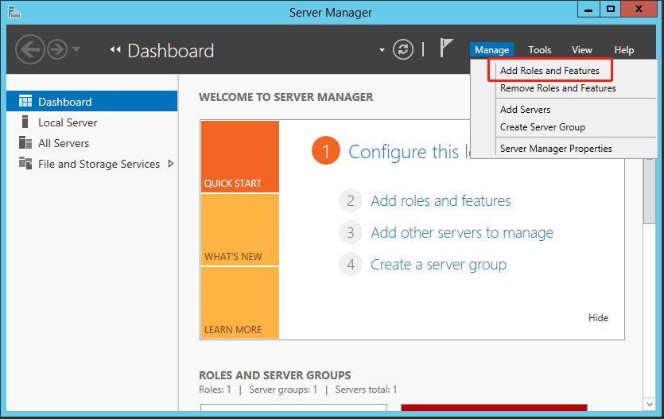

Step 3. Select the destination server. Then press Next.

Step 4. Click Windows Server Migration Tools under Features tab. Then press Next.

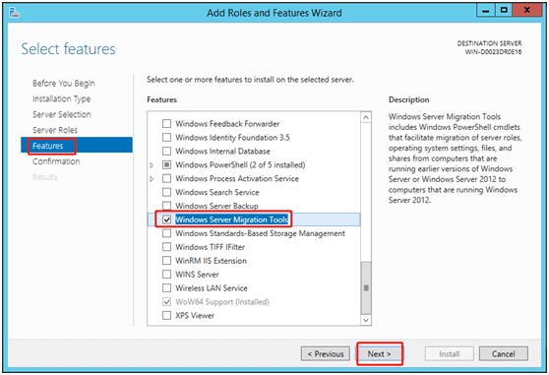

Step 5. Confirm the installation selections. Then click Install to install this tool on the destination computer.

Step 6. Use the method mentioned above to install this utility on the source computer.

Create a deployment folder on the destination computer

Step 1. Press Windows logo key + X. Then choose Command Prompt (Admin).

Step 2. At the command prompt, change to the directory in which the smigdeploy.exe tool is stored. Type the following command. Then press Enter. cd %Windir%\System32\ServerMigrationTools\

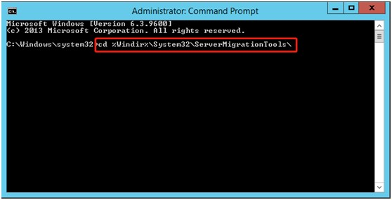

Step 3. Type the following command. Path represents the path of the deployment folder on the source computer. Then press Enter.

SmigDeploy.exe /package /architecture X86 /os WS08 /path

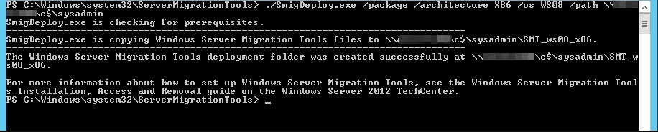

Register Windows Server Migration Tools on the source computer

Step 1. Copy the deployment folder that was created by the destination computer to a local drive of the source computer. Make sure that the operating system architecture of the deployment folder matches that of the source computer.

Step 2. Press Windows logo key + X. Then select Command Prompt (Admin) to open a Command Prompt window on the source computer.

Step 3. At the command prompt, change to the directory to which you copied the deployment folder in Step 1.

Step 4. Type the following command to register Windows Server Migration Tools cmdlets. Then press Enter.

.\Smigdeploy.exe

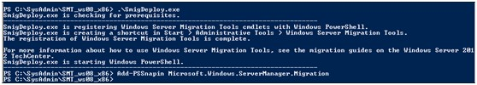

Now you have completed all the preparations. Let’s learn how to use Server migration tools.

Use Windows Server Migration Tools step by step

If you want to export the local users and groups from the source Server, you can follow these steps.

Step 1. Click Server Manager and Tools subsequently on the source Server. Then click Windows Server Migration Tools to open it.

Step 2. Run the following command:

Export-SmigServerSetting -User All -Group –Path C:SysAdminExportMigUsersGroups – Verbose

If you want to import the local users and groups to the target Server, you can refer to these steps.

Step 1. Open Windows Server Migration Tools on the destination Server （Server Manager ﹥ Tools ﹥ Windows Server Migration Tools).

Step 2. Type the following command and then press Enter.

Import-SmigServerSetting –User Enabled –Group -Path C:SysAdminExportMigUsersGroups Verbose

Although Windows Server Migration Tools in 2016/2012/2008 Server can help uses transfer data, the operating steps are complex, especially for some non-technical people.